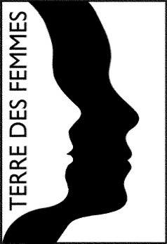

TERRE DES FEMMES e. V.

Brunnenstr. 128,

13355 Berlin, Germany

Tel. +49 30 40504699-0

Fax +49 30 40504699-99

Email: [info@frauenrechte.de](mailto:info@frauenrechte.de)

www.frauenrechte.de

**TERRE DES FEMMES – Menschenrechte für die Frau e.V.**

**CHILD PROTECTION POLICY**

adopted by the Board,

Berlin, 12 October 2017 –

Updated version 29/07/2025 by the child protection officer

TERRE DES FEMMES (TDF) is a German non-profit women’s rights organisation. We are committed to ensuring that girls and women can live a free, equal, and self-determined life while holding equal and inalienable rights regarding all aspects of life. Our aim is to raise public awareness by means of education and advocacy, campaigning and lobbying, international networking, and individual counselling. We collaborate with a number of independent partner projects and women’s rights organisations abroad to support their efforts to help girls and women.

Our primary goal is to end gender-based discrimination, violence, and exploitation. This means that children’s rights need to be protected during all our activities. TERRE DES FEMMES is committed to ensuring that all necessary steps are taken at all levels of our work to safeguard the wellbeing, health, and dignity of children participating in TERRE DES FEMMES activities.

This child protection policy outlines TERRE DES FEMMES’s commitment to protecting children from harm. It establishes rules of conduct for all TERRES DES FEMMES activities to ensure that all children who come into contact with our organization are protected from any kind of harm. The policy adheres to internationally recognized standards set up by international children’s rights instruments (especially the UN Convention of the Rights of the Child) and the Keeping Children Safe Coalition.[1] This policy applies to employees as well as to all partners with whom we operate contractually and with whom we organize projects together. The code of conduct is signed by all TERRE DES FEMMES employees and interns.

# Goals of this child protection policy

**TERRE DES FEMMES aims to**

* **protect children** by minimising risks of harm to children throughout our work and projects. All aspects of this policy apply to both analogue and digital spaces. The safety of children is paramount.
* **protect children from violence** and help those with particular difficulties in getting help because of their gender, ethnicity, age, religion, disability, or sexual orientation.
* **protect all TERRE DES FEMMES employees, volunteers, and its project partners** by setting clear guidelines about how to behave with children and what to do if there are concerns about the safety of a child.
* **protect the reputation and credibility of TERRE DES FEMMES** by clearly stating our commitment and practices to keeping children safe.

# Definitions

**Child –** TERRE DES FEMMES considers every human under the age of eighteen to be a child.

**Child abuse**– Child abuse refers to intentional, negligent, or repeated actions that result in physical, emotional, or sexual harm to children. This includes physical violence, neglect, sexual abuse, and emotional mistreatment.

**Child sexual abuse** – Child sexual abuse (also called sexual violence against children) refers to any sexual acts conducted with or in the presence of a child under the age of 14, because the child cannot comprehend the significance of the actions, cannot give consent. These acts may be physical, verbal, or visual, encompassing sexual harassment, exploitation, coercion, or forced involvement in pornographic representations.

**Digital violence** - Violence on the internet refers to the application of physical, verbal, or psychological force exercised through digital communication means and online platforms. This includes various forms such as threats, harassment, discrimination, cyberbullying, dissemination of violent content, or targeted attacks on individuals or groups. Internet violence can have significant impacts on mental well-being and safety, especially for children who may find it challenging to protect themselves online.

**Neglect** - Child neglect refers to the persistent or repeated failure to meet basic physical, emotional, or social needs crucial for the normal development and well-being of a child.

**Best interest of the child** – is a child rights principle, which derives from Article 3 of the [UN Convention on the Rights of the Child](http://www.ohchr.org/EN/ProfessionalInterest/Pages/CRC.aspx), which says that “[i]n all actions concerning children, whether undertaken by public or private social welfare institutions, courts of law, administrative authorities or legislative bodies, the best interests of the child shall be a primary consideration.”

**Child protection –** is the responsibility that organisations working or in contact with children. They have to make sure that their employees and partners do no harm children in the context of projects and activities. They need policies and procedures in place to minimize the risk of harm to children. They report concerns about children’s safety to the appropriate authorities.

**Child protection concern ­–** refers to the situation when an allegation is made, even if it is unlikely to be substantiated, that a child is being abused or is likely to be abused.

**Employee ­–** refers to anyone who works for or on behalf of TERRE DES FEMMES on a full-time or part-time basis. This includes interns and those working on short-term contracts.

**Partner organisations –** are those organisations involved in joint projects with TERRE DES FEMMES. Organisations that cooperate with TDF in projects involving direct contact with children have to either have or develop their own child protection policy or comply with our code of conduct.

# Preventative Measures

## Code of conduct

The aim of the code of conduct contained in the Annex is to ensure that TERRE DES FEMMES employees, volunteers, and partners take joint responsibility for the safety of children. An additional aim is to protect those persons from false allegation regarding their conduct towards children. During job interviews, orientation discussions, and the onboarding phase, the code of conduct is handed out and discussed. All employees must sign this code of conduct. Partners that come into direct contact with children must sign the code of conduct as well. Awareness about this policy and the code of conduct should be spread to all TERRE DES FEMMES volunteers and partners. All employees and interns receive an introduction and refresher training every six months. According to their tasks and responsibilities, employees will continuously deepen their knowledge on the subject of child protection.

## Periodic checks

TERRE DES FEMMES is committed to a regular review of the child protection policy every six months. All legal changes are incorporated.

## Safe recruiting

A human resources policy geared towards child protection aims to avoid that people will seek to be involved in TERRE DES FEMMES activities in bad faith in order to get access to children. The hiring and selection procedure addresses the extent to which the vacant position entails direct contact with children and where the corresponding risks for inappropriate conduct might lie. Employees hired for positions involving direct contact with children will need a certificate of good conduct (“erweitertes Führungszeugnis”) (renewal every five years) from the police. All employees will sign the child protection code of conduct when starting their position. They will be informed of the TERRE DES FEMMES procedures in the case of allegations of misconduct and the role of the child protection officer and child protection commission.

## Data protection and communication standards

TERRE DES FEMMES has an elaborate [data protection policy](https://frauenrechte.de/datenschutz). Personal data is not handed over to third parties. It is stored in password-protected databases with restricted access.

The counselling centre uses a separate database whose access is restricted to the professional TDF-counsellors. TERRE DES FEMMES has developed a separate consent form for handling images of children. This form must be signed by a legal guardian, explicitly granting permission for the use of the images. Subsequently, the images may be used based on the applicable EU-GDPR regulations.

As part of its activities, TERRE DES FEMMES regularly engages with children directly or indirectly in various projects and campaigns, such as the school theater project "My Heart Belongs to Me!" TERRE DES FEMMES routinely monitors digital content shared with children to ensure it is appropriate, age-appropriate, and safe. Some of our social media or public relations campaigns are directly targeted at children. This means that even in the areas where no direct contact with children occurs, child protection matters. Child protection is part of all phases of PR and awareness-raising campaigns. TERRE DES FEMMES consciously uses sensitive language when dealing with children to protect their emotional well-being. Trigger warnings are also issued to ensure that potentially distressing content is handled with care.

## Joint projects

TERRE DES FEMMES is involved in joint projects with partner organisations in Germany and in other European countries. Our partner organisations are contractually obliged to have their own child protection policy or to sign the TDF child protection policy if they do not have one. Child protection is a key concern in all phases of joint projects: development, implementation, and monitoring. The project managers communicate this child protection policy and code of conduct to partners to ensure that children’s rights are protected.

## International cooperation

TERRE DES FEMMES is a member organisation of [VENRO](https://venro.org/start), a German network of development and humanitarian aid NGOs. VENRO and TERRE DES FEMMES recognize that humanitarian aid should strengthen children’s rights and prevent harm and abuse.

TERRE DES FEMMES supports several projects and women’s rights organisations in other countries, some of which involve girls. Harm prevention and support provision is the core of these projects. TERRE DES FEMMES is committed to raising awareness for child protection in our international cooperation and encourages the inclusion of child protection measures in these projects. The directors of the women’s rights organisations sign the code of conduct as a step towards the development of their own child protection policies.

# Accountability

Every TERRE DES FEMMES employee or partner is responsible for protecting children. The director and heads of department are responsible for monitoring the adherence to this child protection policy.

# Child protection concerns: case management

This is the procedure that occurs in the case of an allegation of child abuse or another child protection concern.

**Suspected cases involving TDF employees or partners**

* The reporting person contacts the TDF Child Protection Officer and reports a suspected case. The child protection officer at TERRE DES FEMMES can be reached at [kinderschutz@frauenrechte.de](mailto:kinderschutz@frauenrechte.de). Reports of suspected child abuse or misconduct are taken seriously, with the highest priority placed on the child's protection. Each suspected case is therefore tracked and documented. There should be no pre-judgment of the accused, and all parties involved are obligated to maintain confidentiality. For a sensitive and professional approach to the respective issue, it is decided on a case-by-case basis which individuals from the departments can be involved. Until the allegations have been clarified, the suspected TDF employee will be removed from direct work with children and young people or suspended.
* Legal guardians are informed of the suspected case and involved in the entire process.
* The Child Protection Officer and a specialist (doctor, psychologist, lawyer) conduct a conversation with the presumed victim.
* A conversation is also held with the accused person to confirm or dismiss the suspicion. Protocols are maintained for both discussions.
* If the suspicion is not confirmed, the case is documented, analyzed, and archived. The TDF employee who was suspected until then receives support in her rehabilitation.
* In the event of confirmed suspicion, the Child Protection Commission is convened to discuss further steps. The TERRE DES FEMMES child protection commission consists of the TDF child protection officer, the Director of TERRE DES FEMMES, and the head of the department in question.
* If the case violates the TDF Code of Conduct but is not criminally relevant, it constitutes a breach of contractual obligations. Internal sanctions, including warnings, reprimands, and termination, may follow.
* If the suspicion of child endangerment is substantiated and is criminally relevant, the TDF director takes responsibility for initiating legal proceedings.
* The case is concluded with a comprehensive analysis, reporting, and measures for improvement. Individual conversations with reporters and affected parties are conducted again, and if necessary, rehabilitation measures are taken. All steps are implemented in compliance with the GDPR.

**Suspected cases involving third parties**

* If the suspected case involves individuals not affiliated with TDF employees or partners, it is reported by the child protection officer to the youth welfare office and the relevant law enforcement authorities.

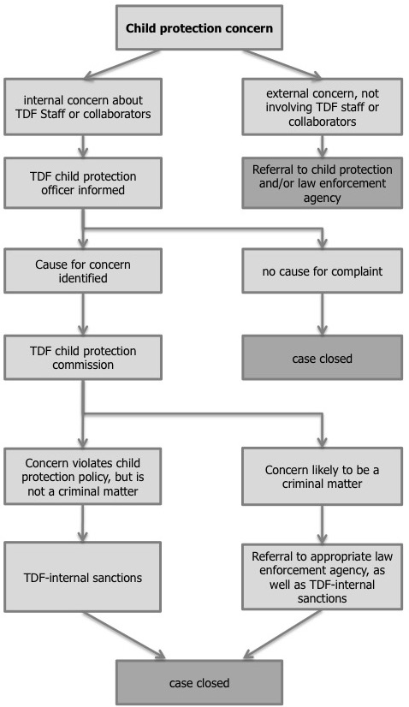

# TDF - Child Protection Policy:

# Code of Conduct

TERRE DES FEMMES is committed to ensuring that children are protected from abuse within the organisation, at our events, as well as in the digital realm, and in connection with our work. Accordingly, TERRE DES FEMMES has instituted preventative measures within the organisation and projects to minimise the risk of abuse and violence against children. The aim of this code of conduct is to guide employees and partners in their interaction with children in order to take responsibility for the safety of children.

Name:

Position:

(employee, volunteer, project partner)

**By signing this document, I undertake to comply with TERRE DES FEMMES’ child protection policy and to** **respond immediately to any concerns, allegations, and incidents, and notify the TERRE DES FEMMES child protection officer without delay at kinderschutz@frauenrechte.de.**

I will

* contribute to creating a safe, nurturing, and empowering environment for children.
* take children‘s beliefs and concerns seriously and foster their personal development.
* treat all children as independent individuals and with respect, regardless of their origin, gender, possible disabilities and chronic illnesses, language, religion and beliefs, sexual orientation and gender identity, or any other status.
* respect the privacy of children and adolescents.
* adhere to the two-person rule and avoid being alone with a child (This also applies to the digital space), except in emergencies. If compliance with the rules is not possible due to an individual consultation or conversation, I will inform at least one other person about the reasons, as well as where and when it takes place
* respect children‘s human dignity and their need to be protected at all times when taking photographs, filming, or writing reports for public relations work; in particular, this also applies to handling their personal data with care.
* respect and treat the legal guardians of children and adolescents with dignity.

This means that I will not

* abuse my position and negatively influence the life and well-being of a child.
* strike a child or assault them physically in any way; disciplinary measures will never entail physical or verbal violence or humiliation.
* abuse or exploit a child sexually, physically, or emotionally; in particular I will never engage in sexual activities with a child or expose it to any pornographic material.
* hug, pat, kiss or touch a child in any manner that is inappropriate or culturally insensitive.
* use any language that is inappropriate, indecent, discriminatory, or abusive.
* provide a child with unsolicited help to perform intimate acts that the child can manage alone (such accompanying the child to the toilet or changing the child‘s clothing).
* develop a relationship with children that could be regarded as exploitative, abusive, or sexual.
* spend a disproportionately large amount of time with a child away from other children.
* tolerate or facilitate illegal, dangerous or abusive conduct toward children.
* Publishing or sharing digital content that may be inappropriate, not age-appropriate, or harmful to children.
* engage in an intimate and/or sexual relationships with a child or engage in any conduct or communication of a sexual nature with a child. The age of the child involved is irrelevant. It is also irrelevant whether the relationship is heterosexual, homosexual, consensual, non-consensual, or condoned by parents or caregivers.

Should I have concerns about possible breaches of this code of conduct, I will immediately contact the TERRE DES FEMMES child protection officer. Notification of any possible contraventions is essential to safeguarding children.

I have read and understood the code of conduct carefully and I have been informed that TERRE DES FEMMES will take internal sanctions and measures in case of a violation. I am aware that breaches of this child protection policy and code of conduct will be dealt with in accordance to relevant German laws.

Date:

Place:

Signature:

(Please send a signed copy to TERRE DES FEMMES)

1. The Keeping Children Safe Coalition is a network of organisations working together to improve child protection through the development of safeguarding standards. See also [www.keepingchildrensafe.org.uk](http:www.keepingchildrensafe.org.uk).